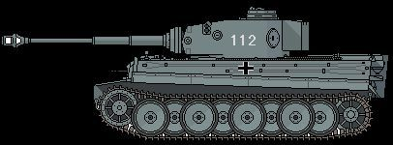
Figure 1Panzer leher
2nd Pz
+2

